**Exercise 3.**

Time/Transient Analysis and FFT and Fourier.

Table of Contents

List of Figures 1

Abstract 3

Part 1: Cyclic charging of the capacitor 4

Part 2: RLC circuit 6

Part 3: Analog adder circuit 10

Part 4: Analysis of the rectifier circuit with the Graetz bridge. 15

Part 5: Wien Bridge Oscillator 18

Part 6: Homework 21

# List of Figures

Figure 1 Diagram of the tested RC circuit. 4

Figure 2 Transient analysis of RC circuit. 4

Figure 3 Modified Circuit RC. 5

Figure 4 +/-25% Capacitance change. 5

Figure 5 Modified Circuit. 6

Figure 6 Charging Capacitor. 6

Figure 7 Presenting phase-inversion. 7

Figure 8 Presenting the values in separate windows. 7

Figure 9 Modified Circuit 8

Figure 10 Comparison showing the change in resistance impact 8

Figure 11 Circuit presenting resistor change value. 9

Figure 12 Plot presenting modified circuit characteristic. 9

Figure 13 Voltage Adder 10

Figure 14 Presenting the input and output waveforms. 10

Figure 15 FFT of 3 signals input 11

Figure 16 FFT of output 11

Figure 17 .four directive. 12

Figure 18 Spice Error Log Fourier Analysis. 13

Figure 19 Transformer Circuit. 15

Figure 20 New Symbol Schematic. 15

Figure 21 Rectifier with Graetz bridge. 16

Figure 22 Plot Characteristic 16

Figure 23 Rectifier with Graetz bridge with different capacitor values. 17

Figure 24 Output Plot Characteristic. 17

Figure 25 VT+/- with output plot characteristic. 17

Figure 26 Wien Bridge Circuit. 18

Figure 27 Result Characteristic. 18

Figure 28 Circuit showing Wien Bridge Circuit. 19

Figure 29 FFT Results of Wien Bridge. 19

Figure 30 Wien bridge oscillator (sine wave generator) with nonlinear elements (AGC). 20

Figure 31 Plot Characteristic. 20

Figure 32 FFT Results of AGC. 20

Figure 33 Wien Bridge Symbol 21

Figure 34 Wien Bridge FFT output 21

# Abstract

The aims of this laboratory exercise were to learn about the possibilities of time analysis/transients Transient. To determine FFT and Fourier analyzes as well as creating new elements – transformer in LTspice.

# Part 1: Cyclic charging of the capacitor

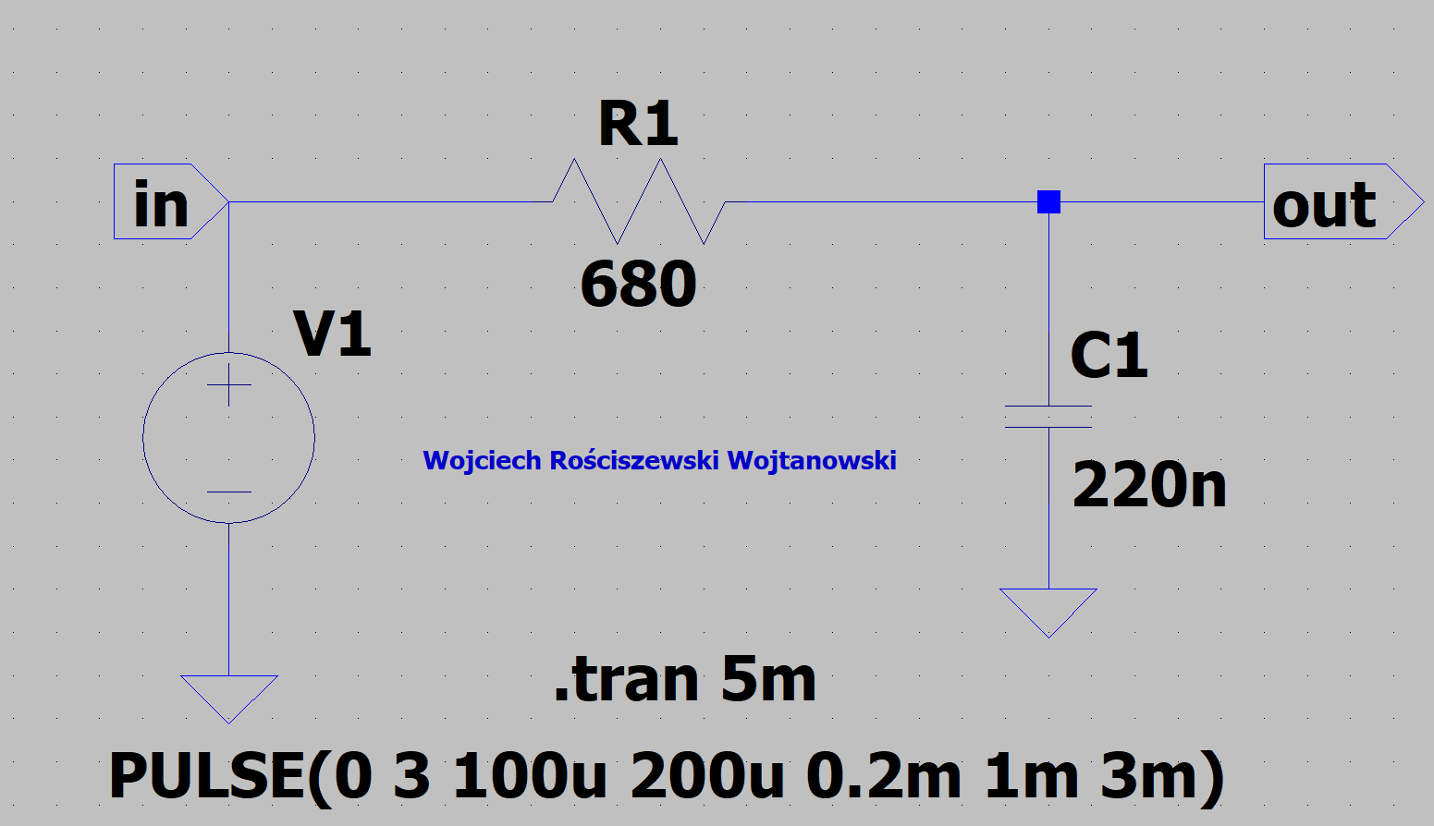

Figure 1 Diagram of the tested RC circuit.

Pulse function has been set visible in the Figure 1, can be done by clicking with RMB over V1 and selecting the Advanced mode button in the source settings. Below please find the Transient analysis, in the circuit tested in Figure 1 we see a .tran 5m command directive for SPICE that is responsible for setting the observation time of our simulation to 5ms. Below see results in figure 2.

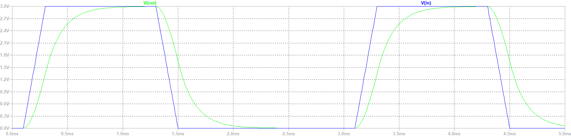

Figure 2 Transient analysis of RC circuit.

Please see the blue more square pulse being our input pulse function in our source function, whilst the curved pulse like green line presents the output we see the effects of our circuit. I suspect that the capacitor is doing a lot of filtering, so it charges at the start of the pulse progressively, reaches maximum capacity, then once the pulse has finished there is still energy in our capacitive element so we have a curve as the capacitor is being discharged. I assume if we change the values in the next task we will see the effects of how the curve will be distributed.

In the below please seek Figure 3 that presents the slightly modified circuit with step.

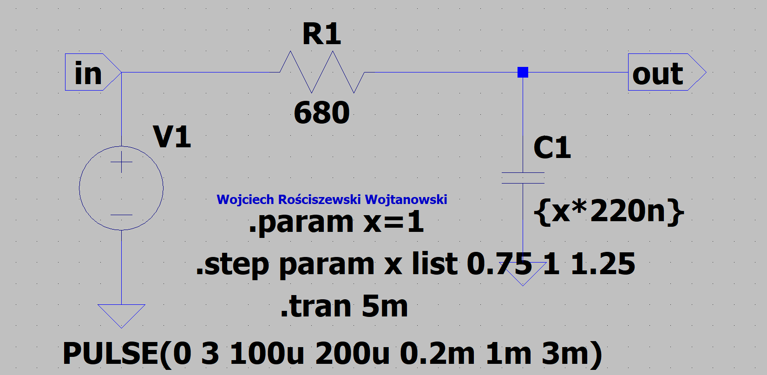

Figure 3 Modified Circuit RC.

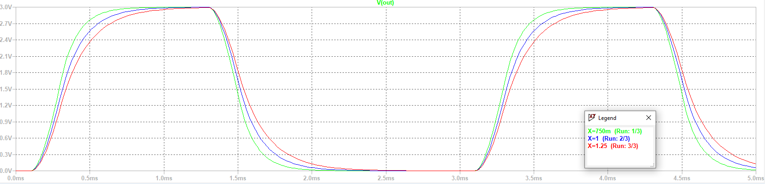

Figure 4 +/-25% Capacitance change.

As we can see the lower the capacitance value the lesser the curve difference is, whilst the larger the capacitance the greater the difference of change from the original pulse signal.

# Part 2: RLC circuit

In the next stage of the experiment we see a capacitor charging circuit presenting how capacitors are charged over time. See that the voltage source is 10V (DC) and using the .IC we set the initial conditions of the current through the coil I(L1) and the voltage across the capacitor V(out) to value of zero. Seek that the observation time of the entire simulation has been set to 10ms, and the maximum timestep in our field view with the value of 1 µs.

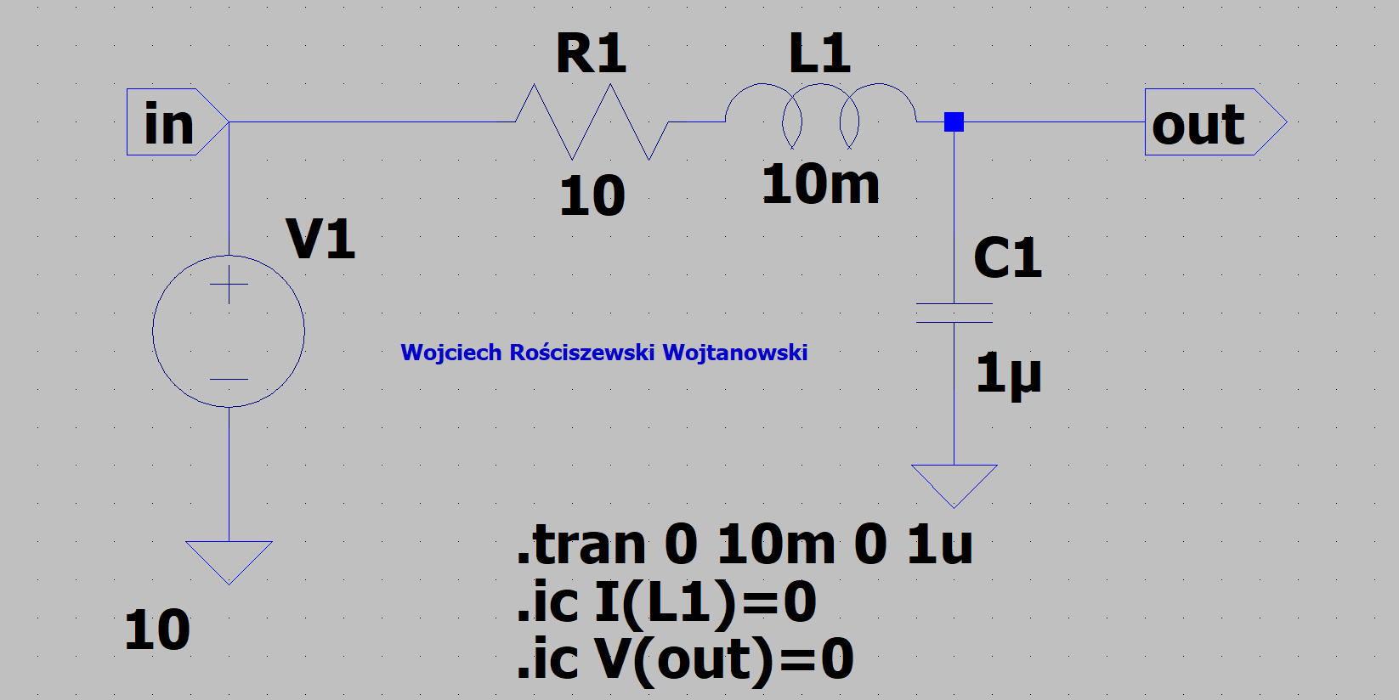

Figure 5 Modified Circuit.

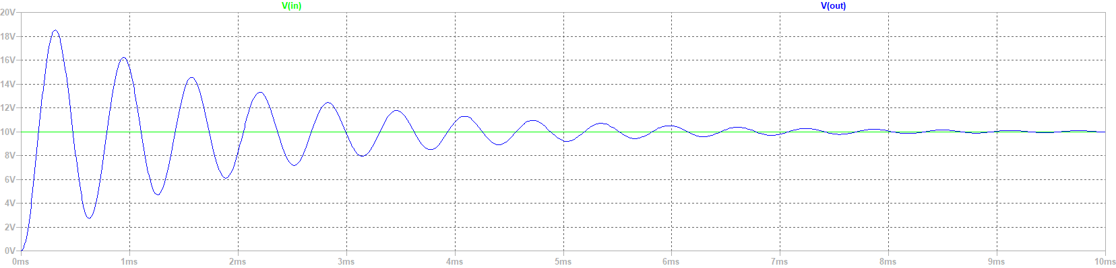

Figure 6 Charging Capacitor.

We see that the voltage across the resistor, is in phase, whilst the coil and capacitor are out of phase with original input., else known that they are 180o opposite each other. Since the coil leads the current by a phase of 90o and the capacitor instead lags by a phase of 90o so in total we have a full 180o phase inversion. See figure 7 presenting this, red is R1 whilst blue and (not visible) green is C1 and L1.

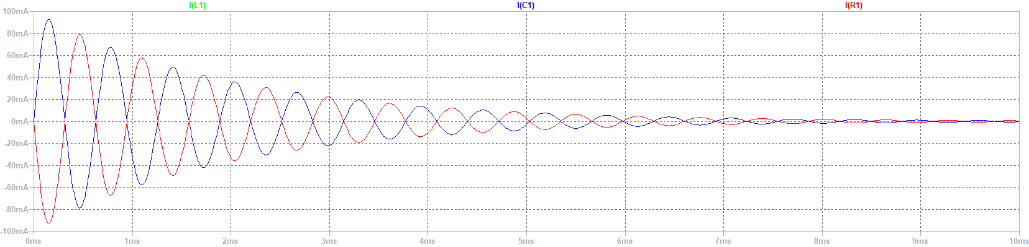

Figure 7 Presenting phase-inversion.

Please see the current and voltage in separate graphs.

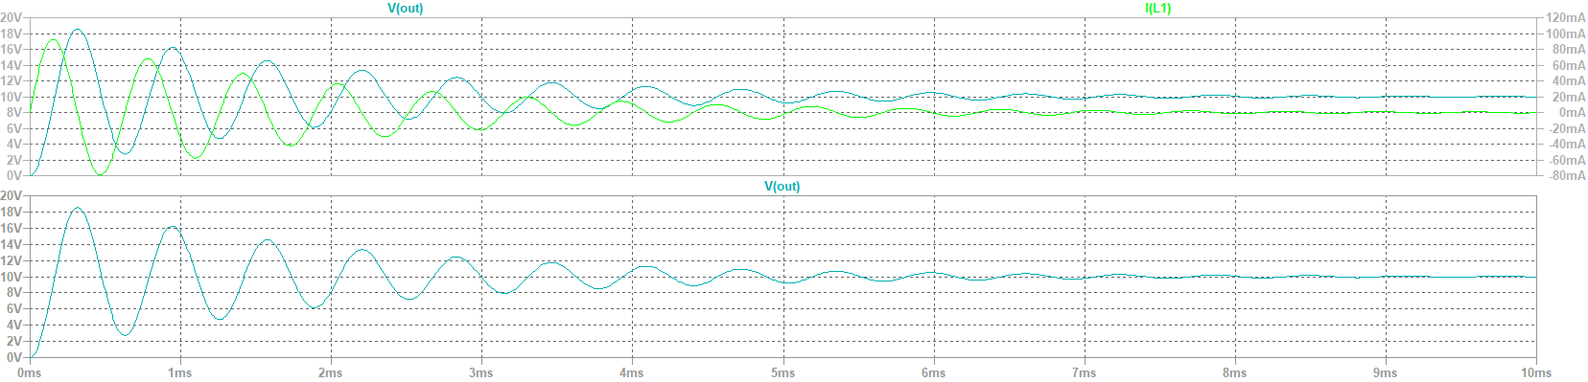

Figure 8 Presenting the values in separate windows.

For the next part of our exercise we will modify the circuit presented above to show how the waveform is affected by changing the values of R1. We will take the values of 10Ω, 50Ω and 100Ω

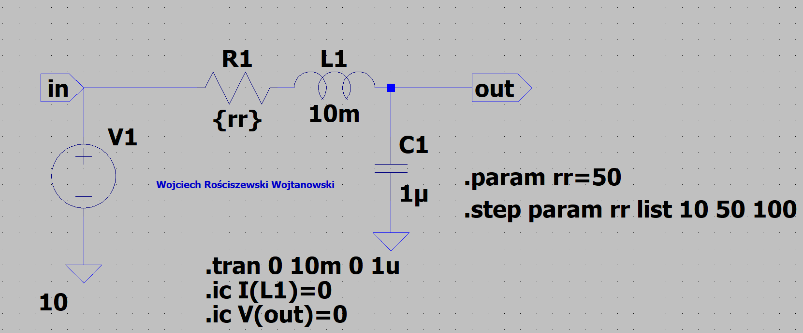

Figure Modified Circuit

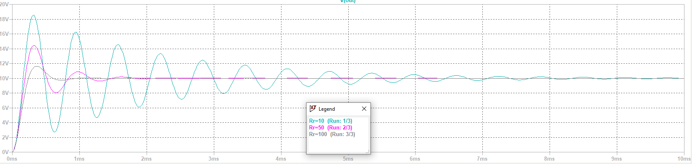

Figure 10 Comparison showing the change in resistance impact

We see the lower the resistance the lesser the voltage, the higher the resistance the higher the voltage.

Next step is to modify the circuit according to our first tasks circuit, we modify voltage course and capacitance values.

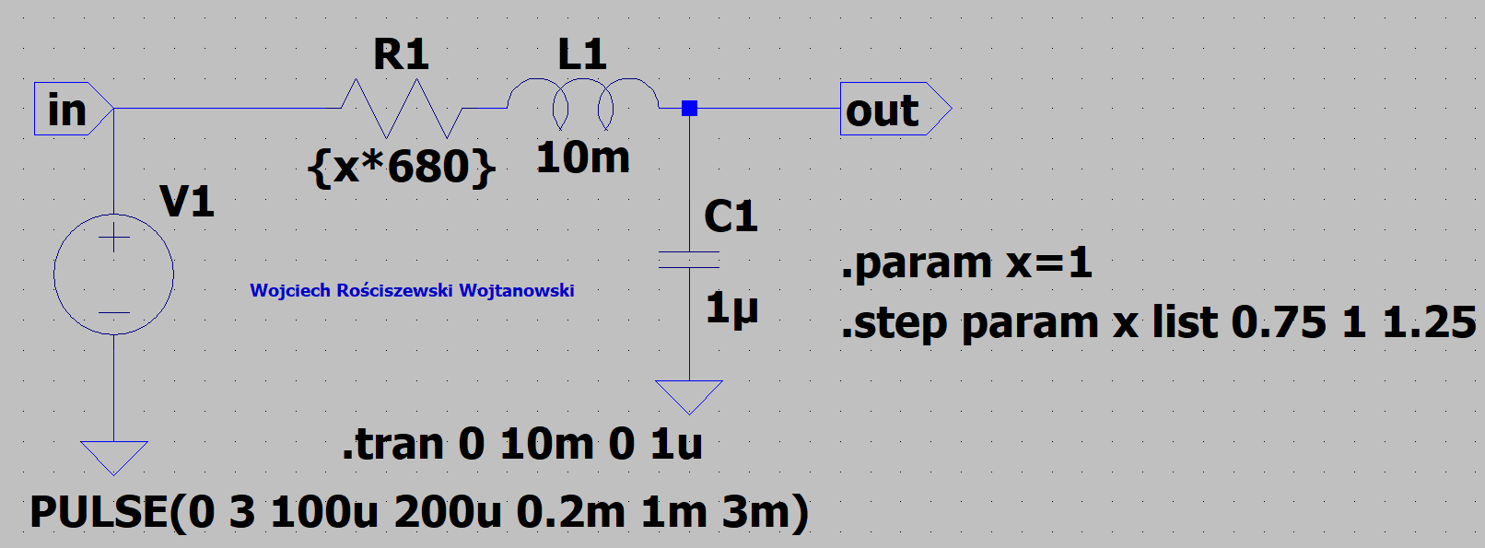

Figure 11 Circuit presenting resistor change value.

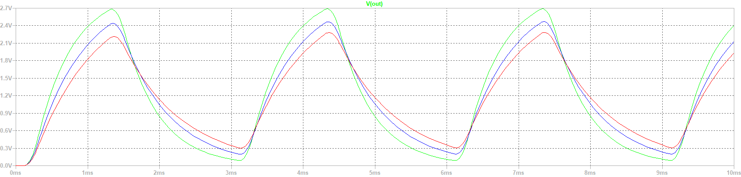

Figure 12 Plot presenting modified circuit characteristic.

We see the green value is the lower resistance of -25% meaning the higher the resistance the lower voltage is and vice versa.

# Part 3: Analog adder circuit

In the below please see the voltage adder circuit. The values set according to the provided instruction.

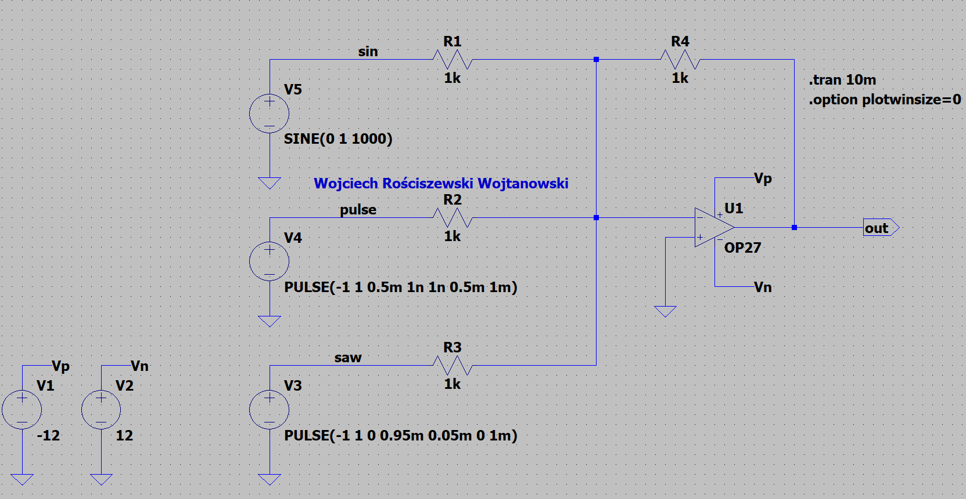

Figure 13 Voltage Adder

Using the .option and .plotwinsize=0 will disable output data compression. Please see the below plots presenting the waveforms on the input and output.

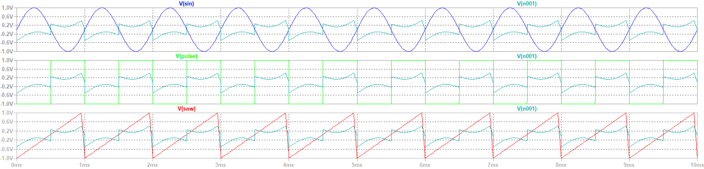

Figure 14 Presenting the input and output waveforms.

See that all three of the input waveforms are different, whilst the output values are all of the waveforms combined. Below please see the FFT analysis.

Input:

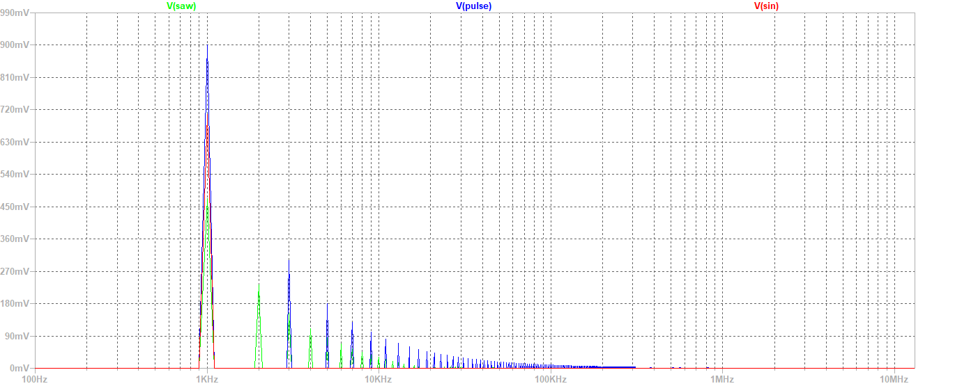

Figure 15 FFT of 3 signals input

Output:  
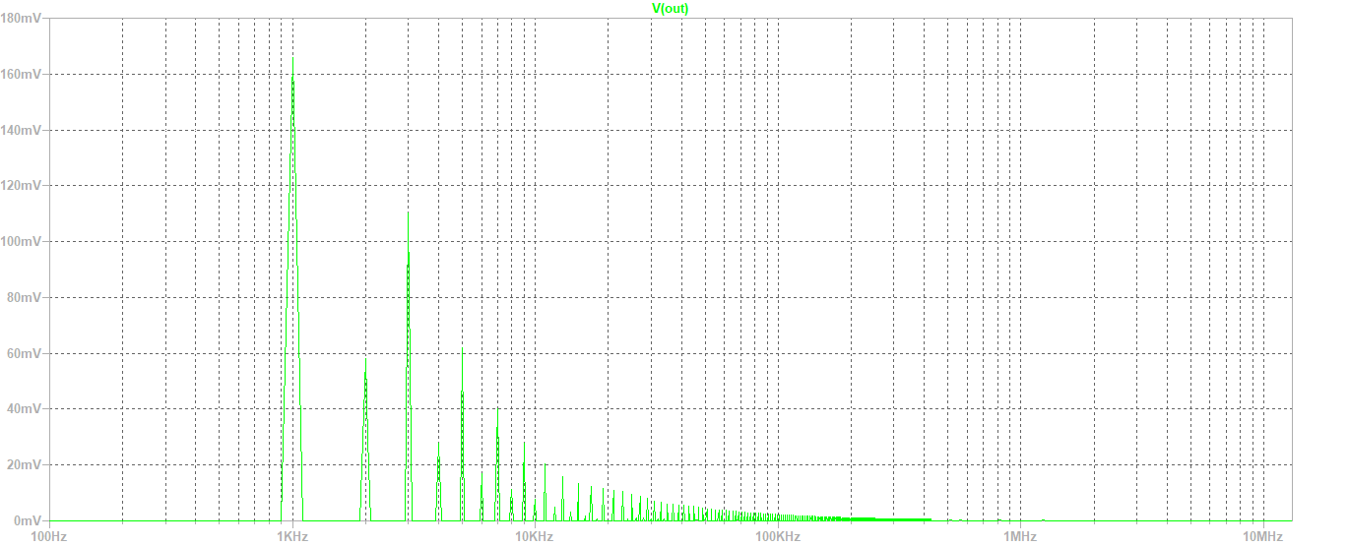

Figure 16 FFT of output

We see that the output signal is simply the multiplication function of all signals combines, therefore approves my previous assumption.

Using .four command directive for SPICE we calculate the Fourier transform for the input and output signals, by defining the new functions. See figure below.

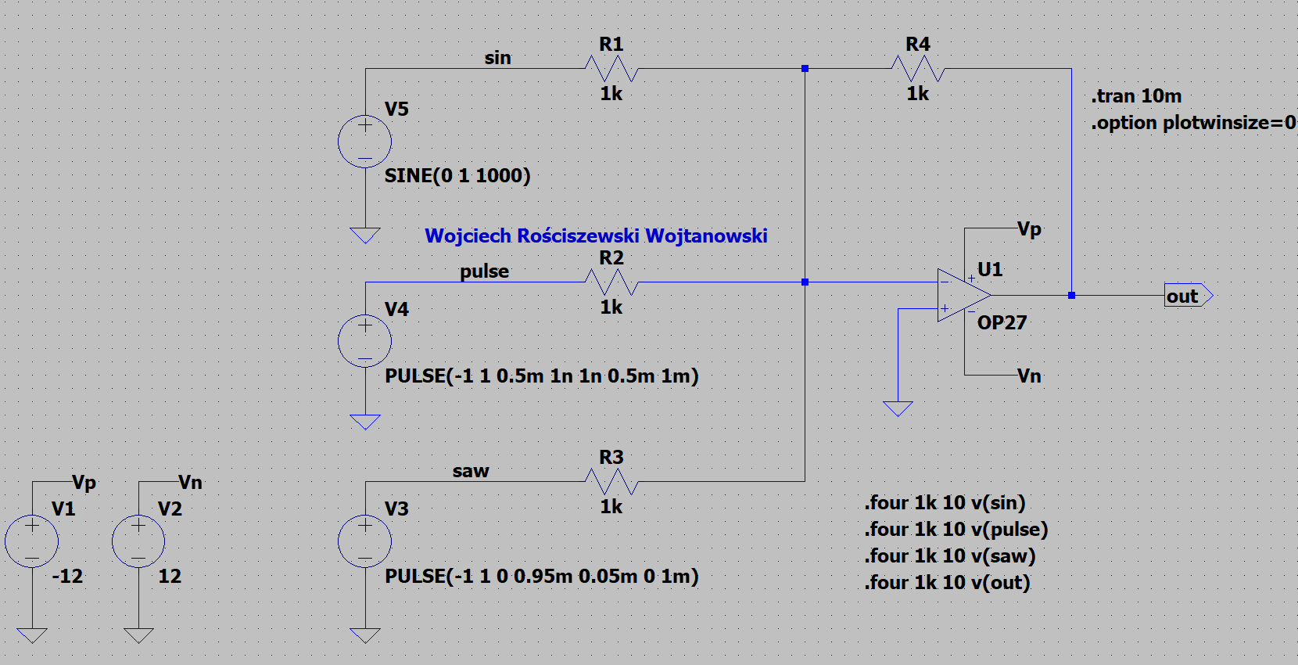

Figure 17 .four directive.

Spice error log screengrab:

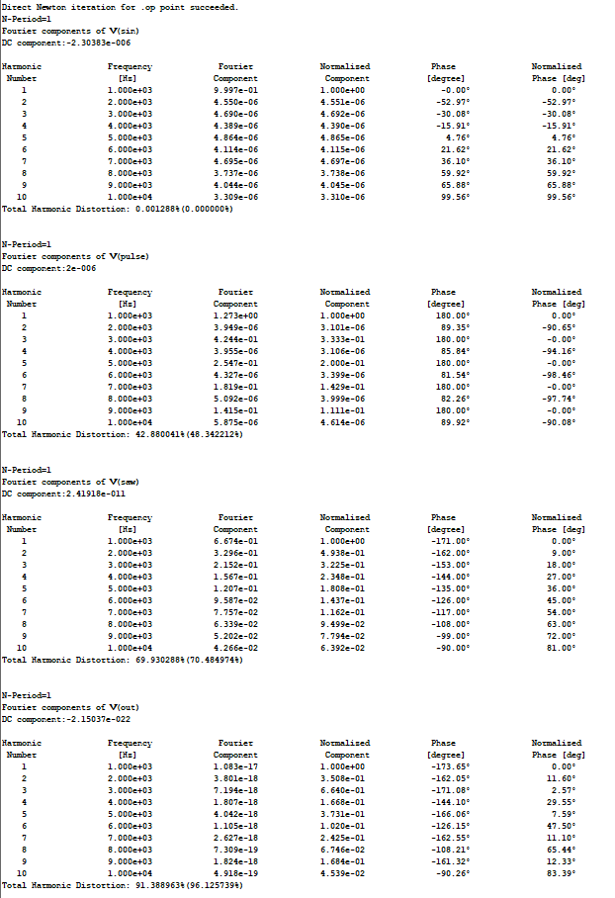

Figure 18 Spice Error Log Fourier Analysis.

By changing the resistor values, we can manipulate how the system affects on the input signals at the output. However, we must keep in mind that all values must be different as by having the consistent values will result in the same results. All signals will match the characteristic shown in the figures above.

# Part 4: Analysis of the rectifier circuit with the Graetz bridge.

For this part of the exercise we edit the SPICE preferences, mostly by selecting the new path for saving symbols to a newly created folder named CAD in my documents.

Then we draw a diagram as instructed of a transformer. In the figure below please see the mentioned circuit. Notice the port types, we have input and output considering all possibilities of negative and positive types (using labels). Coupling of coils K1 L1 L2 1 as the spice directive.

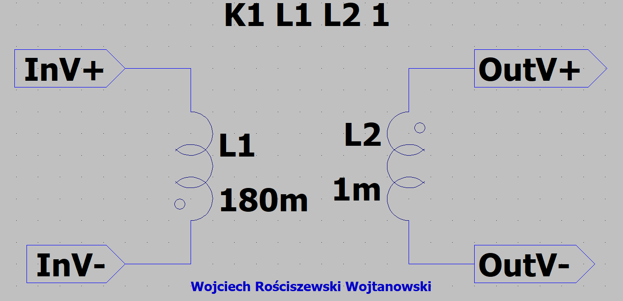

Figure 19 Transformer Circuit.

The next step is to set the series resistance of the coils L1 to 100mΩ and L2 to 10mΩ. Once done we must save the transformer circuit as a diagram in our previously created location. Created symbol:

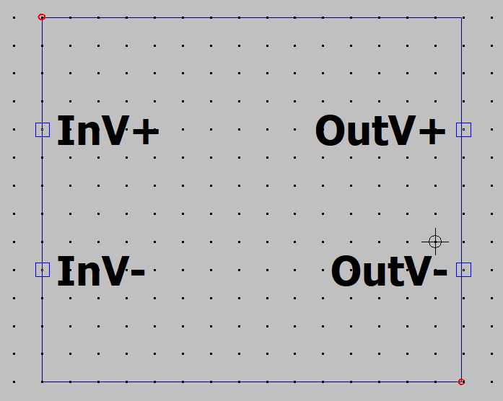

Figure 20 New Symbol Schematic.

Our next step is to create a rectifier with Graetz bridge, please see the figure in the below.

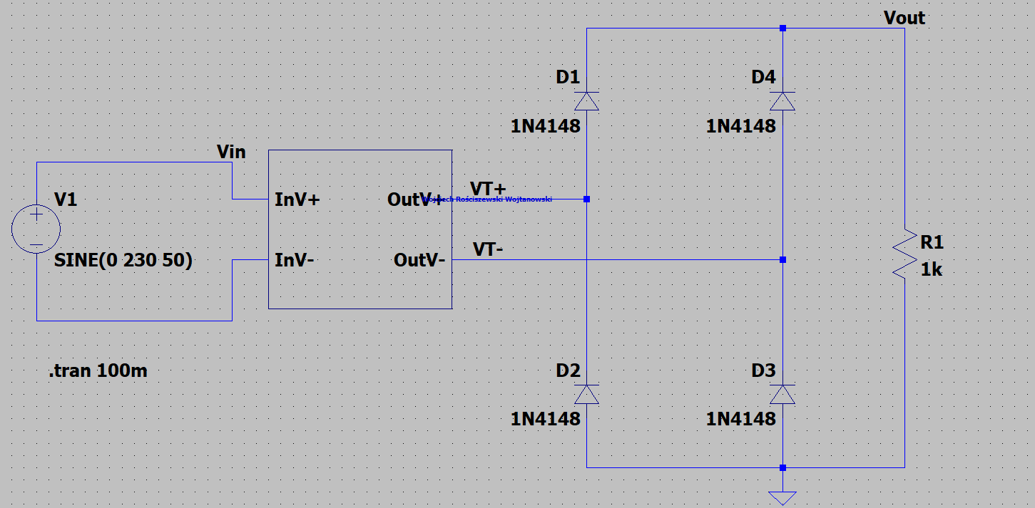

Figure 21 Rectifier with Graetz bridge.

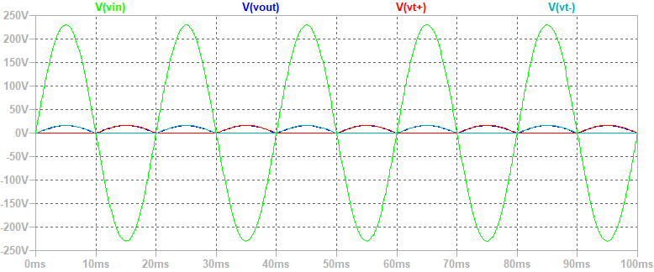

Figure 22 Plot Characteristic

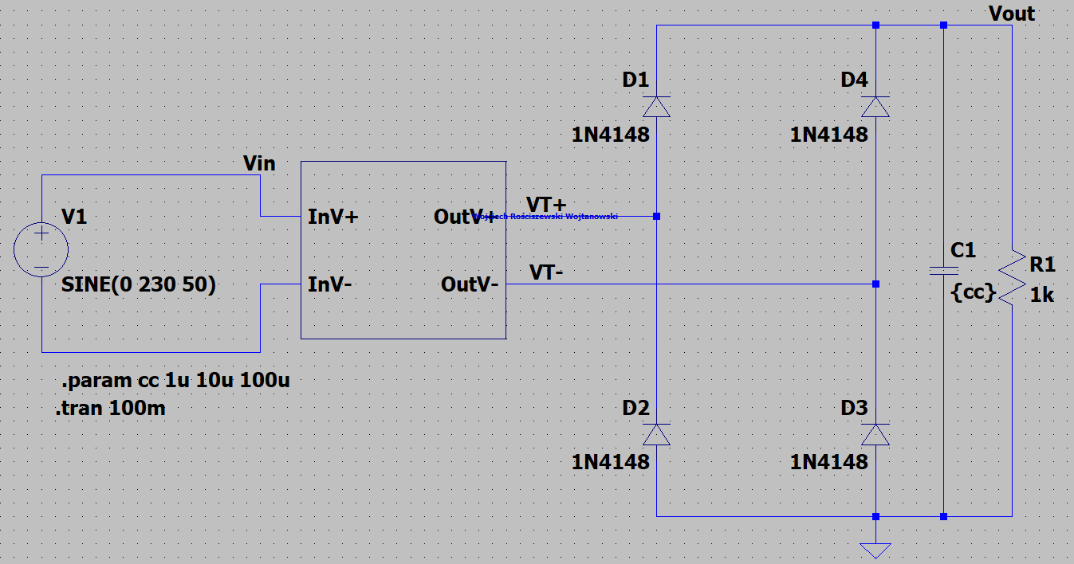

Figure 23 Rectifier with Graetz bridge with different capacitor values.

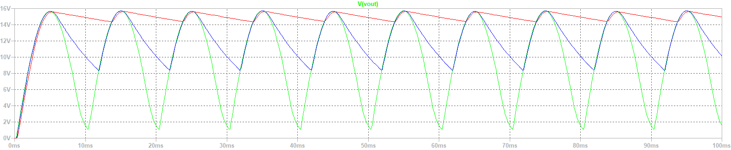

Figure 24 Output Plot Characteristic.

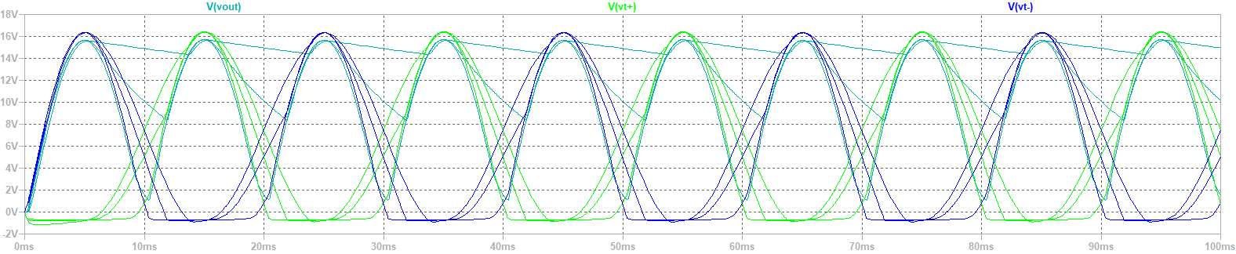

Figure 25 VT+/- with output plot characteristic.

K1 is the ideal transformer parameter. From the graphs we see that a current is passing through the voltage source and the load resistor, as well as capacitor respectively. We see the capacitor charging and discharging affecting the overall shape of the waveform. It is more and more curvy and straight rather than a somewhat continuous pulse of sinusoids.

# Part 5: Wien Bridge Oscillator

For the next exercise we created a Wien bridge circuit shown in figure below.

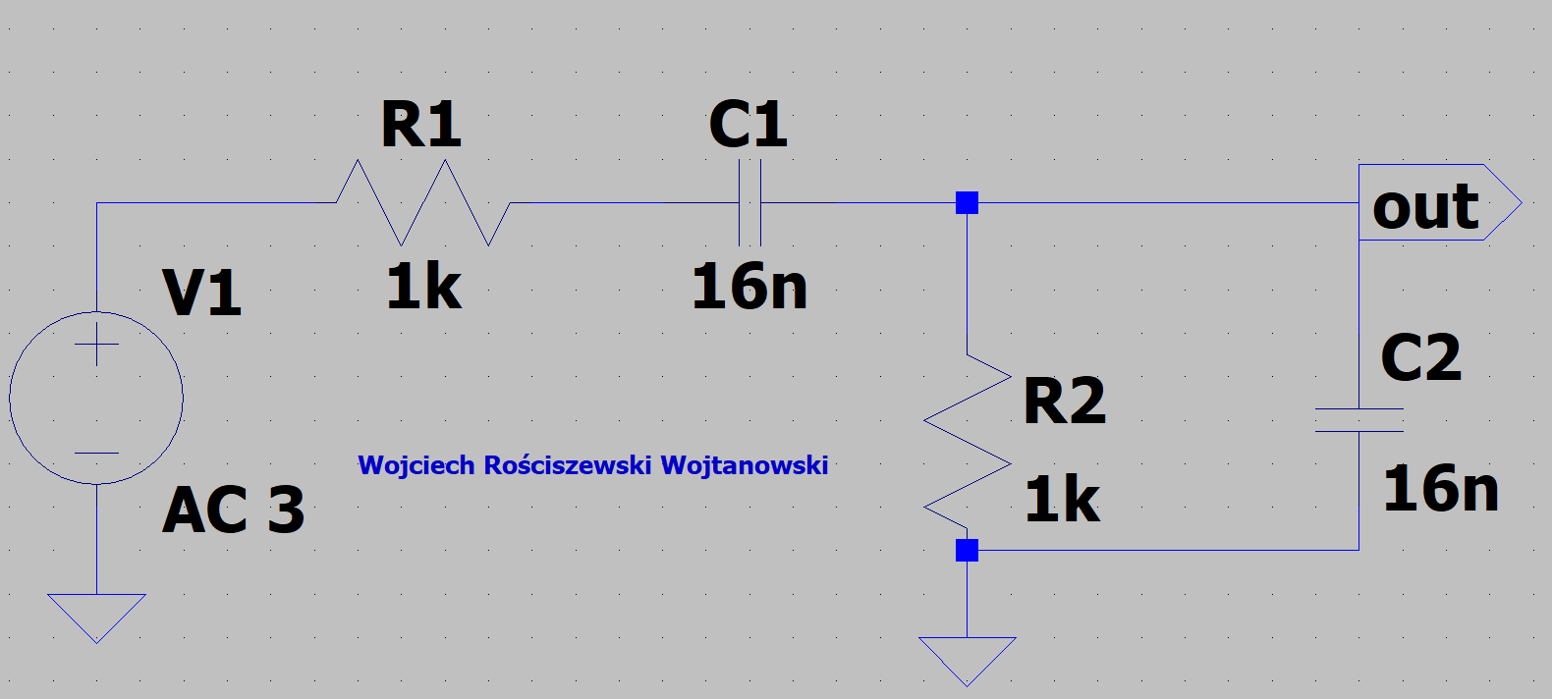

Figure 26 Wien Bridge Circuit.

By use of the AC frequency analysis we were to find the value of the frequency f0 for which the phase shift between the output and the input is 0. We have additionally found the attenuation of the Vout/Vin bridge for this particular frequency. Using directive .ac dec 1k 100 1meg I have stepped the AC analysis.

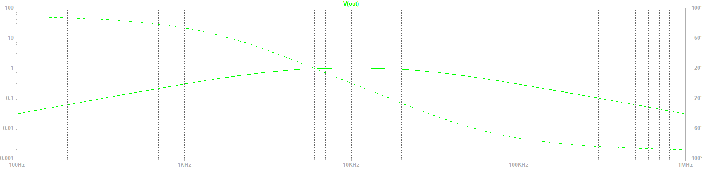

Figure 27 Result Characteristic.

f0=9,95kHz and has been calculated using the formula f0=

Next part is to create the following wien bridge circuit. Please see the results in figure below that.

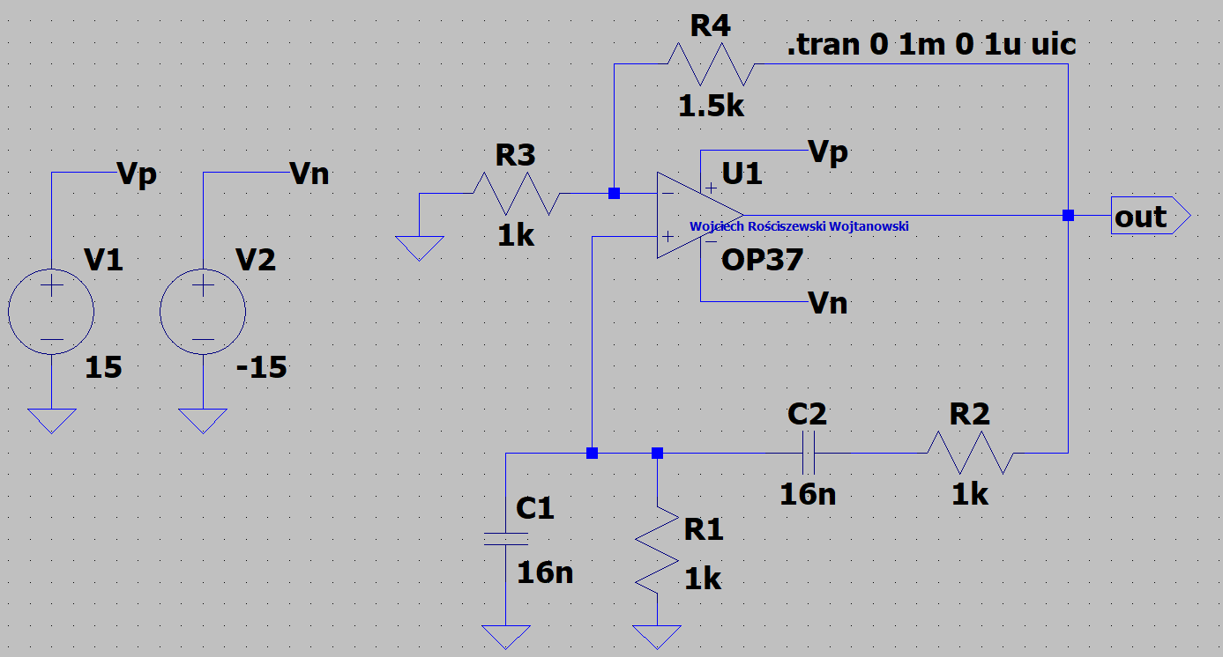

Figure 28 Circuit showing Wien Bridge Circuit.

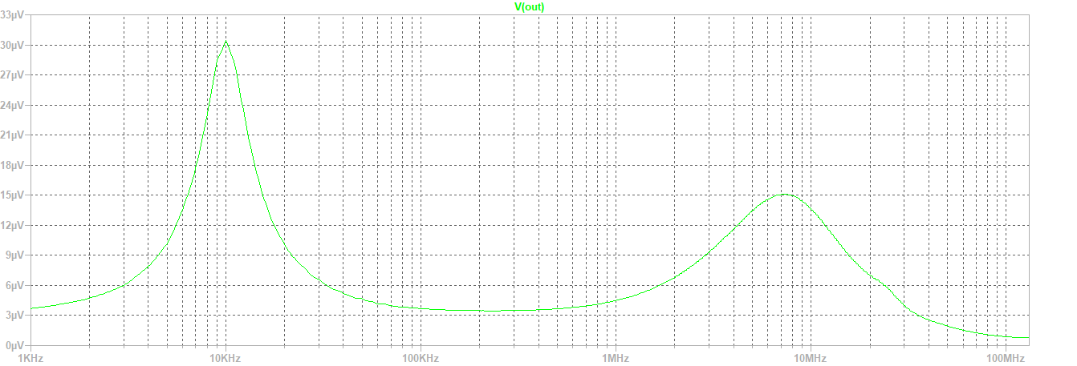

Figure 29 FFT Results of Wien Bridge.

In the below please see the new circuit.

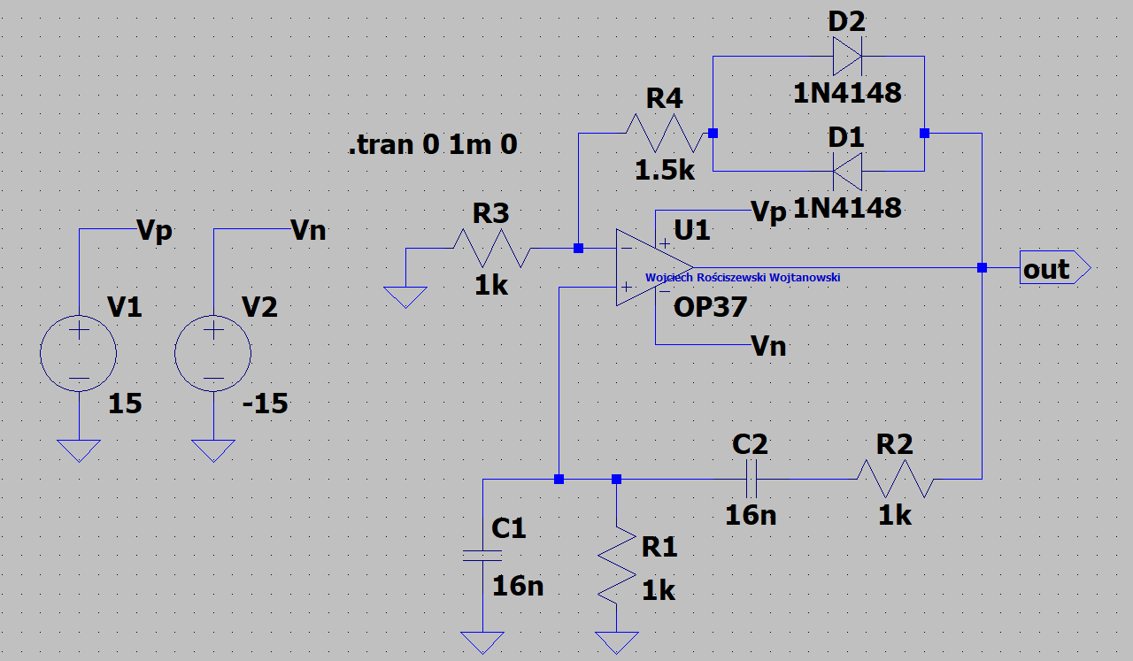

Figure 30 Wien bridge oscillator (sine wave generator) with nonlinear elements (AGC).

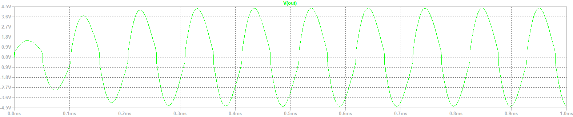

Figure Plot Characteristic.

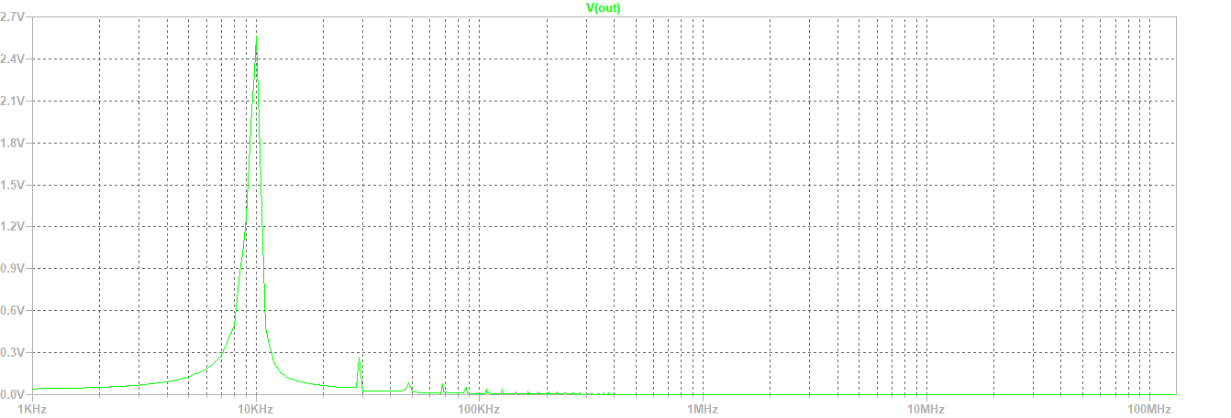

Figure 32 FFT Results of AGC.

# Part 6: Homework

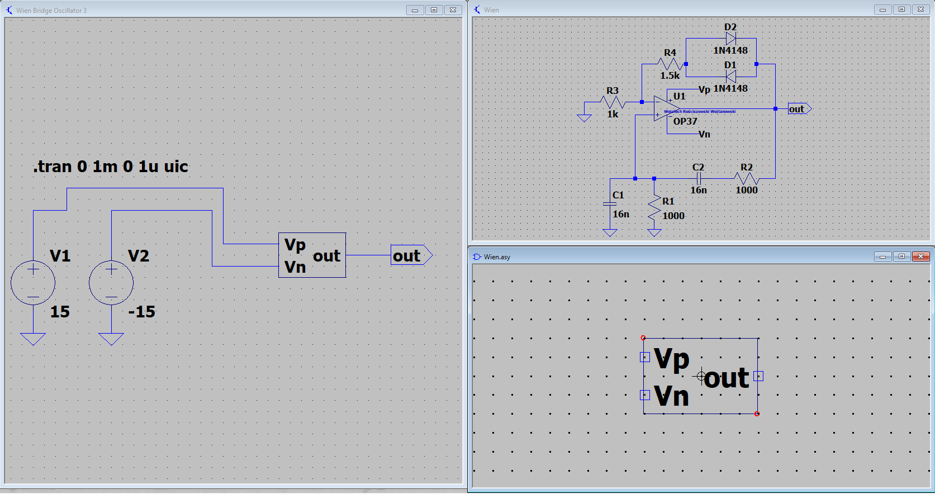

Figure Wien Bridge Symbol

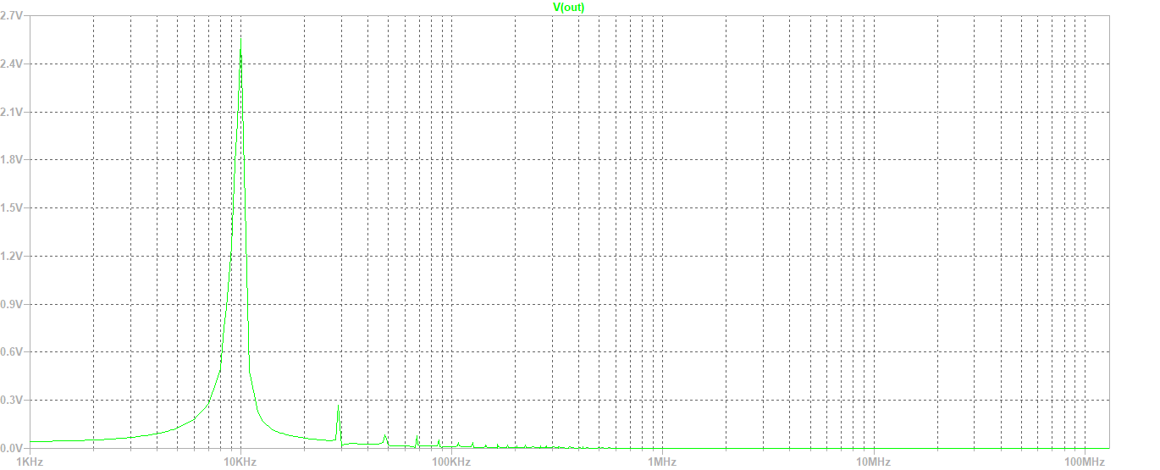

Figure 34 Wien Bridge FFT output

Success, symbol is working as it should.